Rural Broadband I.D. Expenses Trust Fund Grant
Supplemental Guidance
This Supplemental Guidance provides detailed instructions, suggestions, examples, and templates that applicants may choose to use in applying for the Rural Broadband I.D. Trust Fund Grant program. Use of this guide is NOT REQUIRED. It is only meant to support applicants in answering questions should they need additional support. Whether the applicant uses this guide to apply for the Rural Broadband I.D. Trust Fund Grant program will not determine their proposal’s funding decision.
What is the Rural Broadband I.D. Grant?
It’s a one-time grant to pay for the cost of a study to determine if broadband is needed in an area and the expenses needed to get it there.
Essential Resources:
The Rural Broadband ID Grant Notice of Funding Opportunity
https://idhi.uams.edu/rural-broadband-grant/grant-description/
Rural Broadband ID Grant FAQ page
https://idhi.uams.edu/rural-broadband-grant/grant-faqs/
Broadband Resources webpage for helpful toolkits and guidelines
**NEW – A Sample Application is now available here**
https://idhi.uams.edu/rural-broadband-grant/broadband-resources/
Tasks to Complete Your Application:
How to Define Your Proposed Service Area:
List the counties, unincorporated communities, cities, or incorporated towns to be served through this proposal.
- If you will serve an entire county, only list the county name.
- If you will serve multiple counties, list each county name.
- If you will only serve one community, city, or town, only list that name.
- If you will serve certain communities, cities, or towns in a county, list all applicable.
No map is required for this response; however, you may use a map with a boundary line to indicate your proposed service area. Here is an example taken from Google Maps (https://www.google.com/maps):
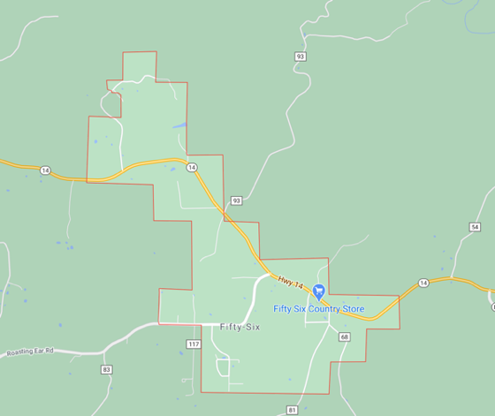
How to Determine your 25/3 Broadband Availability:
This is best achieved through two related maps and legends. See instructions below.
Map 1:
- Go to https://broadbandmap.fcc.gov/#/
- You can search a few different ways. You may use whatever method fits best for your application.
- Enter the address of your main office or other key locations by using “Search by Address.”
- Enter your area by selecting “Area” below the search bar. You will be directed to a page that has a search box with a drop-down menu to search by State, County, Congressional District, Census Place, Tribal Area, or CBSA (Core-Based Statistical Areas, which includes large and medium sized areas).
- Once you enter your address or area, you will be taken to the “Location Summary” page with a map and list of Internet Service Providers.
- You can zoom in or out for detail. Zoom out until you feel the map shows all the proposed service area you wish to target.
- Capture an image of the map and legend of providers to include in your application. This can be done a few different ways:
  - If you’re using Microsoft Windows (Source: https://www.businessinsider.com/how-to-screenshot-on-windows):
    - Press PrtScn. This copies the entire screen to the clipboard. You can paste the screenshot into any program that displays images, like Paint or Microsoft Word.
    - Press Alt + PrtScn. This copies the active window to the clipboard, which you can paste into another program.
  - If you’re using Apple / Mac (Source: https://support.apple.com/en-us/HT201361)
    - To take a screenshot, press and hold these three keys together: Shift, Command, and 3.
    - If you see a thumbnail in the corner of your screen, click it to edit the screenshot. Or wait for the screenshot to save to your desktop.
- If you have multiple, non-contiguous areas you are targeting in your application, please feel free to provide multiple maps using this method.
- This will produce a map and list of your Internet Service Providers. Include this map and the legend of Internet Service Providers in your application.
An example of Map 1 may look like this:
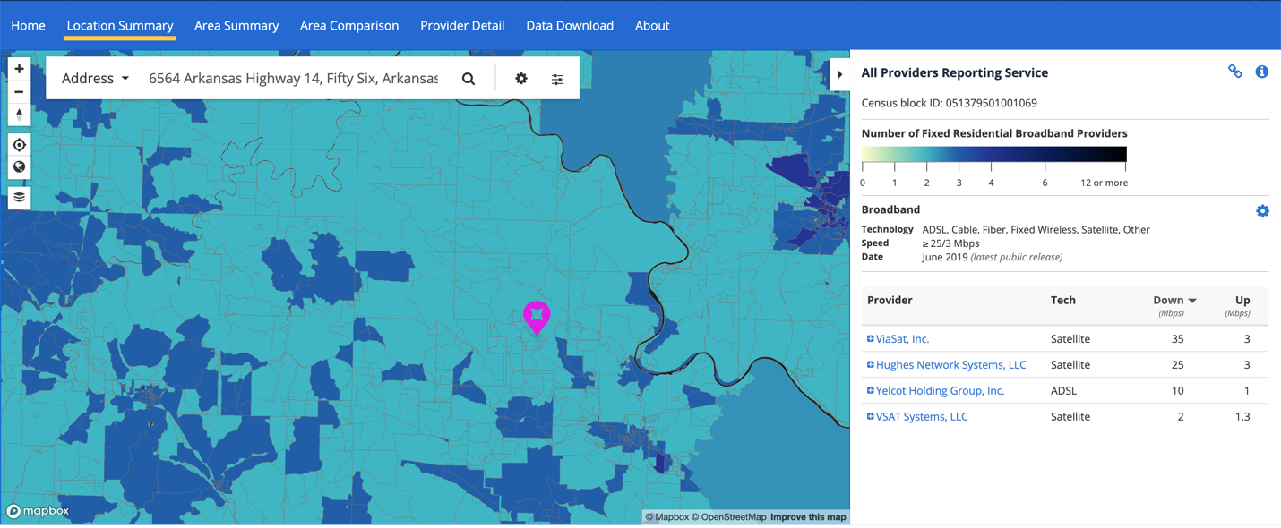

Map 2:
- Stay on the https://broadbandmap.fcc.gov/#/ website.
- Click “Area” under the Search bar.
- You will be directed to a page that has a search box with a drop-down menu to search by State, County, Congressional District, Census Place, Tribal Area, or CBSA (Core-Based Statistical Areas, which includes large and medium sized areas).
- You may use whatever area fits best for your application or that you feel might most accurately represent the broadband services in your area.
- Capture an image of the map and legend of providers offering 25/3 service to include in your application (see instructions under Map 1 above for how to screen capture).
An example of Map 2 may look like this:
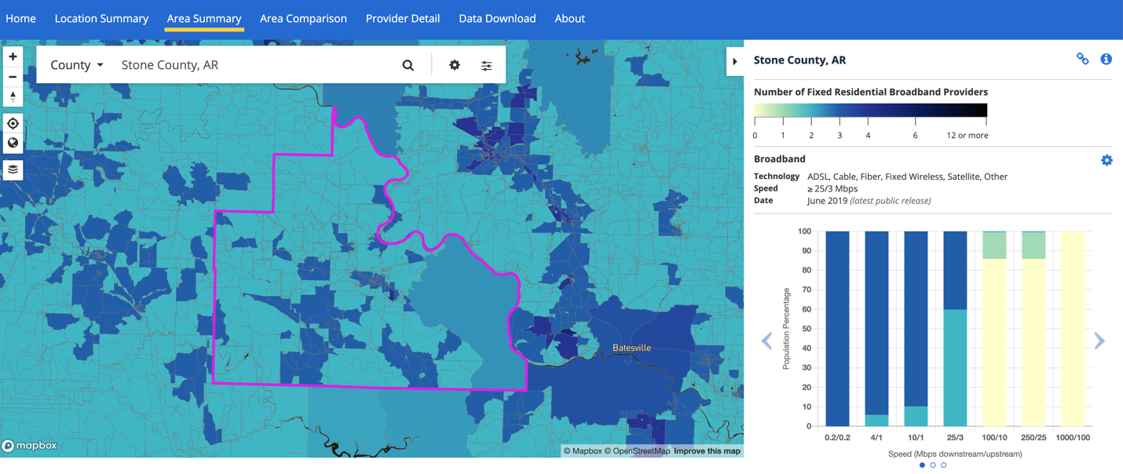
How to Determine Your Total Population:
- Go to https://www.census.gov/data.html
- Enter your city, town, place, county, etc. in the search bar. Hit “Search.”
- The total population will appear in the topmost text box.
- If you have multiple places or counties in your application, please repeat this process for each one. Feel free to list the populations in narrative or table form.
- If you do not see your place listed on this site, please choose the nearest, larger place. For example, for Furlow, Arkansas, you may choose Lonoke, Arkansas.

How to Determine the Rurality of Your Proposed Area:
If you are proposing a place:
- If the place population is 2,500 or less, that place is 100% rural.
- If the place population is over 2,500 but under 50,000, that place is 100% urban cluster.
- If the place population is over 50,000, that place is 100% urban.

If you are proposing a county:
- Go to https://local.arkansas.gov/index.php
- Under the “county” pull-down menu, select your targeted county.
- This will take you to a county summary. Scroll down to “Cities in XXX County.” Check the place populations for these listed cities using the method described above.
  - If the place population is 2,500 or less, that place is 100% rural.
  - If the place population is over 2,500 but under 50,000, that place is 100% urban cluster.
  - If the place population is over 50,000, that place is 100% urban.
- All other places in the county would be considered rural.

If you are proposing multiple places, counties, or a mixture thereof:
- Repeat these steps as necessary for each place or county.
- Provide a summary of your findings to represent the rurality of your proposed area.
- If you must estimate the total percent of rural and urban, please just provide the data on which you made that estimate.

How to Determine Population Living in Poverty:
- Go to https://www.census.gov/data.html
- Enter your city, town, place, county, etc. in the search bar. Hit “Search.”
- Select the blue box “Profile” on the far right of the page.
- The “Poverty Rate” will appear near the top of the profile page, under an icon that looks like this:
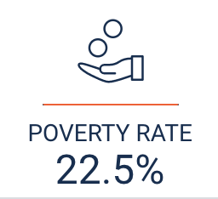
- If you have multiple places or counties in your application, please repeat this process for each place or county. Feel free to list the populations in narrative or table form.

How to Determine Medically Underserved Areas
You can find MUAs two different ways: by county or by address. Only one is needed for your answer, so please use the method that you feel best suits your needs.

By county MUA determination:
- Go to https://data.hrsa.gov/tools/shortage-area/mua-find
- On the leftmost column, select “Arkansas.”
- On “Select County(s) required,” select the location of your proposed area’s county.
- Once you click “Submit,” you will see a table with information. The “Cross” or “Plus” icons on the right most column will pull down a list of Medically Underserved Areas. If you have many rows of information, which may occur in some urban counties, please screen capture what you can fit in your window to give reviewers a good idea of your MUAs.
- Screen shot these tables for your response.
An example of the Medically Underserved Areas county table may look like:
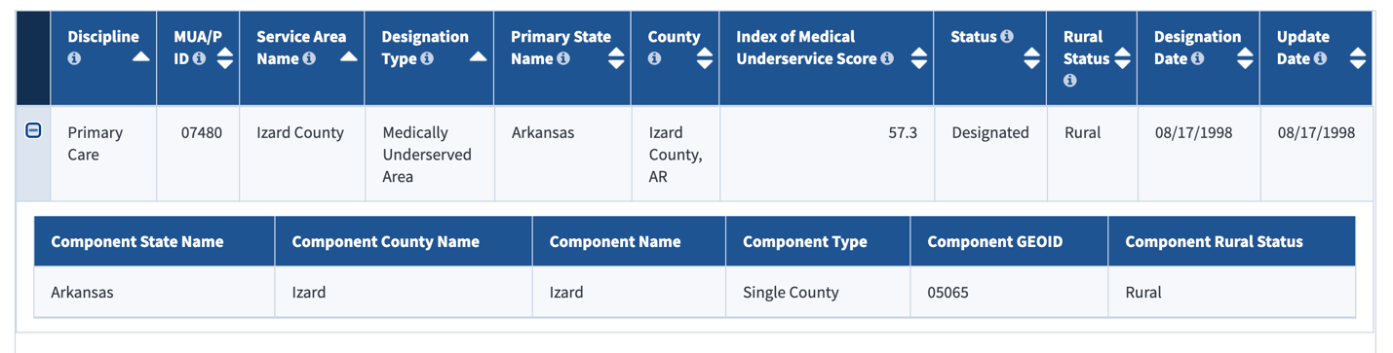

By address MUA determination:
- Go to https://data.hrsa.gov/tools/shortage-area/by-address
- Under “Search Criteria” enter an address in your proposed service area. You may use any address that falls within your proposed service area.
- You may take a screen shot or write down the information provided about MUAs that appear on the left side of the screen.
An example of Medically Underserved Areas address page may look like:

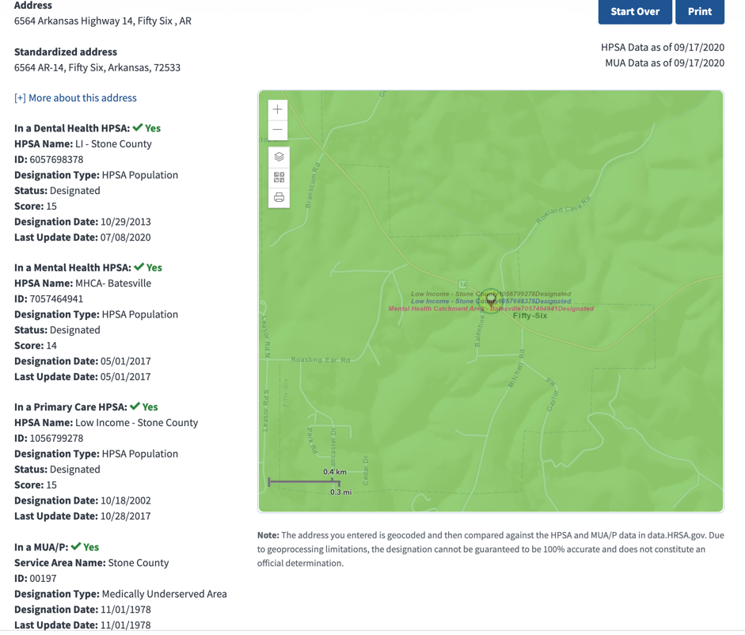
Example Information on Staffing Needs
While any content will be acceptable to describe staffing needs, the following are a few things you may consider including to describe existing experience or lack of staff experience:
- Working with Internet Service Providers
- Experience with technology or broadband
- Working with contractors and consultants
- Writing grant or loan applications
- Managing state or federal funds
- Managing and balancing budgets
- Maintaining timelines and meeting deadlines
- Convening committees
- Carrying out special projects
- Hiring personnel
- Educating or communicating with your residents
- Social media experience
- Or any other experience you find relevant.
Example Information on Population Needs
While any content will be acceptable to describe population needs, the following are a few things you may consider including to describe population needs:
- Demographic info like race, ethnicity, age, income
- Schools in your area
- Healthcare providers, clinics, emergency medical services, or hospitals in your area
- Any known educational needs (e.g. students cannot access online curriculum, graduates cannot access online college coursework, adults cannot participate in online training or education, etc.)
- Any known healthcare needs (e.g. residents with chronic health problems, inaccessibility to nearby healthcare providers, residents who lack insurance, etc.)
- Any known business needs (e.g. ability to conduct e-commerce, businesses that have closed or will shut down, businesses that have moved and relocated elsewhere, lack of workforce, lack of training resources, struggling economies, etc.)

While any source will be acceptable to describe population needs, including anecdotal observations, please feel free to use the following resource as you wish:

- Go to https://www.census.gov/acs/www/data/data-tables-and-tools/data-profiles/
- Using the radio buttons under “2014-2018 ACS 5-Year Data Profile,” select county or place.
- Once you select the “county” or “place” button, a drop-down menu for state appears. Select “Arkansas.”
- Once you select “Arkansas,” another drop-down menu for “Choose a Place” or “Choose a County” appears. Select your place or county.
- Once you select your place or county, a button that says “Get Data Profile Links” appears. Click that button.
- You’ll see options for Social, Economic, Housing, and Demographic Characteristics. Each have good data for your locality.
- Once you click one of the characteristics, you will see a list of related characteristics. Your place our county statistics will appear in the two leftmost columns. Scroll to the right as necessary to view your place or county data.
- Some of characteristics that may interest you include those listed below. These are only suggestions:
  - Social Characteristics:
- School Enrollment
- Educational Attainment
- Computer and Internet Use
  - Economic Characteristics
- Employment Status
- Industry
- Income and Benefits
- Families
  - Housing Characteristics
- Housing Occupancy
- Vehicles Available
  - Demographic Characteristics
- Sex and Age
- Race
- Hispanic or Latino and Race

Example Information on Broadband Needs
While any content will be acceptable to describe broadband needs, the following are a few things you may consider including:
- Any observed variances or personal disagreements in broadband access or speed compared to the FCC coverage map you completed in the first section.
- How broadband access or speed has impacted your:
  - Schools
  - Businesses
  - Residents
  - Community facilities
  - Healthcare facilities
- How your residents could benefit, possibly including:
  - Educational attainment
  - Economy / community revenue
  - Retained jobs / retained businesses
  - Primary or specialty healthcare access
  - Entertainment options
  - Communications between first responders
Example Information on Internet Service Provider Relationship Needs
While any content will be acceptable to describe your relationships with Internet Service Providers (ISP), the following are a few things you may consider including to describe ISP needs:
- Any past communication with ISPs about your community needs
- Any agreements or disagreements with ISPs about your community needs
- Any perspective on customer services provided by current ISPs
- Any alliances your community has made with ISPs

It is also perfectly acceptable to have no past relationship or communication with ISPs.

Example Information on Financial Needs
While any content will be acceptable to describe your financial needs, the following are a few things you may consider including:
- Your current annual budget for your community.
- If proposing multiple communities:
  - The average annual budget of the communities you plan to serve through this proposal, or
  - An itemized list of the annual budgets of the communities you plan to serve through this proposal.
- What that budget covers (fire, police, city salaries, etc.)
- Why this grant may be financially needed, possibly including:
  - Your budget is limited in what it can cover
  - A budget reallocation for these activities would require council approval and may not result in such an approval
  - Some council or civic members do not appreciate the importance of spending money on broadband or broadband planning
  - Other financial needs are more pressing at this time

Example Information on Community Relationship Needs
While any content will be acceptable to describe your community relationship needs, the following are a few things you may consider including:
- A summary of any past discussions with community leaders about broadband
- Whether your community leader(s) support the idea of improving broadband
- Whether any resident or community organization has approached your leaders to appeal for improved broadband
How to Describe Your Plan
While any format will be acceptable to describe your proposed plan, the following is a format you may use to describe your plan:

- Summary of your proposed activities. Some examples of these may include:
  - Contract with an Internet Service Provider to perform a feasibility study for your area.
  - Hire a Certified Public Accountant to perform audits and other financial analyses required for grant proposals.
  - Order construction plans for broadband deployment.
  - Hire a contractor to analyze federal broadband grant and loan opportunities.
  - Form a Broadband Taskforce.
  - Conduct a community-wide broadband needs assessment.
  - Contract with another local government or electrical cooperatives to provide coaching on how they improved their broadband capabilities.
  - Secure consultative support to learn about broadband and the options available to your community.
  - Secure legal support to better negotiate and mediate with Internet Service Providers and/or Electric Cooperatives.
  - Participate in community education, both local or nationally, to improve the understanding of broadband and grant writing.
  - Hire a contractor to pursue federal broadband funding grants and loans.

- Provide a list of any contractors or consultants you have considered hiring through grant funds. It is acceptable if you have not selected contractors or consultants.

- Provide a timeline of these activities. Here’s an example that lists the steps or goals needed to complete each activity you identified above and a way to identify which months will be used to completed those steps :

 | Month 1 | Month 2 | Month 3 | Month 4 | Month 5 | Month 6
Goal 1: Identify first step or goal to complete activity | X
Goal 2: Identify second step or goa; to complete activity | X
Goal 3: Identify third step or goal to complete activity |  | X
Goal 4: Identify fourth step or goal to complete activity |  |  | X
Goal 5: Identify fifth step or goal to complete activity |  |  |  | X | X
….And so on

- List your final products for the broadband due diligence study. These are items that will come into being because of the funding you received and the activities you conducted. Some examples may include:
  - A broadband feasibility study prepared by a contracted ISP
  - A 20-year break-even analysis prepared by a contracted Certified Public Accountant
  - A financial audit prepared by a contracted Certified Public Accountant
  - Construction plans prepared by a contracted broadband construction company
  - A written analysis of broadband grants and loans that may fulfill your needs from a contracted grants researcher
  - A written needs assessment authored by a Broadband Taskforce or other community source
  - Any support materials provided by a contractor that coached or educated your leaders or community on broadband
  - Any legal agreements or materials that secure Internet Service Provider services or future services
  - Any federal broadband grant or loan proposals, even in draft form, that were produced by a grant writer during this Rural Broadband I.D. grant period.
- List any federal broadband grants or loans you have considered pursuing. It is acceptable if you have not considered any of this grants or loans. If you want to investigate some opportunities, here are some opportunities:
  - https://www.usda.gov/reconnect
  - https://www.rd.usda.gov/programs-services/rural-economic-development-loan-grant-program
  - https://www.ncta.com/k12bridge-to-broadband
  - https://www.fcc.gov/document/fcc-proposes-5g-fund-rural-america-0
  - https://www.imls.gov/grants/available/national-leadership-grants-libraries
  - https://www.rd.usda.gov/sites/default/files/USDA_RDSA_COVID-19CUMULATIVEFactsheet_09_09_2020.pdf

How to Budget the Proposal
While any format will be acceptable to budget your proposal, the SF-424A budget provided on the Rural Broadband I.D. website may be easiest, as it automatically totals your request. You should only fill out Section B. The image below only shows those fields you would fill out for this request.

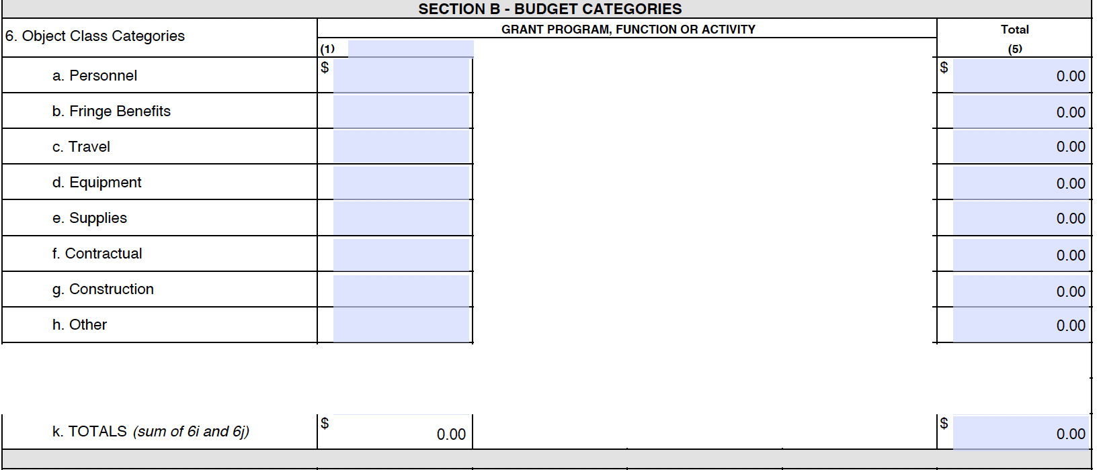

If you’d prefer to use a MS Word budget and hand calculate your totals, here is a template you may use.

Budget Categories | Cost
Personnel | $XXXX
Fringe Benefits | $XXXX
Travel | $XXXX
Equipment | $XXXX
Supplies | $XXXX
Contractual | $XXXX
Other | $XXXX
Total Request | $XXXXXX

Description of Each Budget Category
Personnel: This will include anyone who will work on the grant activities and
1) are currently on your payroll or
2) will be added to the payroll.

For instance, if your treasurer receives a salary from the applicant and will spend one day a week for six months on the grant, 10% of her annual salary can be requested.

If you plan to hire a part-time writer to be placed on your payroll, and he or she will spend all of his/her time on the grant for six months, then 50% of his/her annual salary can be requested.

Fringe Benefits: These only apply to the personnel on your grant and can cover their healthcare benefits, dental benefits, life insurance, or other benefits provided to your personnel. Typically this is shown as a percentage of the annual salary.

Travel: This can include in-state travel, providing mileage reimbursement as needed to carry out grant activities. This may also include out-of-state travel should the applicant decide to seek broadband education or consultation in another state.

Equipment: This may include any item that exceeds $5,000 per unit cost as needed to carry out the activities of the project.

Supplies: This may include office supplies, printing, postage, rental space for meetings, laptops and computers, and other items needed to carry out the activities of the project.

Contractual: This is the cost of any contracted consultants, Internet Service Providers, Electric Cooperatives, writers, or any person or group who will complete activities in the grant but are not on the applicant’s payroll. If you are partnering with another local entity, you can also allocate money to that other entity as a contractor, documenting that cost here.

Other: Anything you do not feel fits nicely into one of the categories above may be included here.

How to Justify your Budget
This is your opportunity to describe what comprises each of your budget categories. If you have multiple items that contribute to the total for any given category, this is the place where you break out those items. The following is an example of how you may justify each category:

Personnel:
Name the person
Name the position
Name their annual salary / hourly wage
Identify the number of hours or percent of effort for the project
Describe what they will do.

Fringe Benefits:
Identify your fringe benefit rate for personnel

Travel:
Identify the miles you intend to travel and the per-mile travel reimbursement requested
Itemize any out-of-state travel by specifying the cost of airfare and boarding
Describe why travel is necessary to the activities of your project.

Equipment:
Itemize any equipment over $5,000 per unit
Describe why this equipment is necessary to the activities of your project.

Supplies:
Itemize any supplies and their cost
Describe how these supplies will be used to carry out the project.

Contractual:
Identify any contractors or consultants you wish to hire
Specify the requested costs for each contractor or consultant
Describe what kind of work these contractors or consultants will be conducting for your project. It is acceptable if you do not have contractors or consultants selected and are just requesting a specified amount to pay the contractor or consultant once identified.

Other:
Itemize any other items or services needed and their associated costs
Describe why these other items are needed to compete your project.

Supporting Documents Templates
While any letter format you wish to use for the supporting document is acceptable, the following are a few letter templates you may feel free to use and customize as you wish:

From Leaders:
**INSERT LETTERHEAD**

*INSERT DATE*

TO NAME
ADDRESS
ADDRESS
ADDRESS

Dear XXXX,

I am writing this to express my full support for your efforts to determine broadband needs for *insert community name* through your proposed broadband due diligence study. Should you receive an award through the state-funded Rural Broadband I.D. Expenses Trust Fund Grant, I will assist in *list ways you can help*. *please explain your expertise and how it pertains to broadband needs* *state why this grant may be important for your community.*

What a great opportunity to improve our community!

Warm Regards,

**INSERT SIGNATURE**

*Insert name and credentials*

From Residents:

**INSERT LETTERHEAD**

*INSERT DATE*

TO NAME
ADDRESS
ADDRESS
ADDRESS

Dear XXXX,

I am aware that you plan to apply for an award through the state-funded Rural Broadband I.D. Expenses Trust Fund Grant. I fully support this initiative to determine broadband needs in our community and will personally assist through *indicate how you can help*. In my experience, many of *community name*’s residential broadband needs include *insert any needs you’ve observed*.
*Please indicate why access to affordable, reliable broadband is important to you.*
Thank you for your time and your consideration of these matters. I am truly excited for what this grant can do for our community.

Sincerely,

**INSERT SIGNATURE**

*Insert name and, if applicable, credentials*

From Internet Service Providers / Electric Cooperatives:

**INSERT LETTERHEAD**

*INSERT DATE*

TO NAME
ADDRESS
ADDRESS
ADDRESS

Dear XXXX,

Please accept this letter of support on behalf of *insert ISP / Electric Cooperative name* for XXXX’s proposed broadband due diligence study that would be supported through the state-funded Rural Broadband I.D. Expenses Trust Fund Grant.
My organization will *describe how you intend to help* with the goal of potentially providing and/or improving broadband coverage.*please state your commitment to providing improved access to reliable, affordable broadband in the community*
I look forward to helping with this broadband initiative.

Sincerely,

**INSERT SIGNATURE**

*Insert name and credentials*

From Businesses

**INSERT LETTERHEAD**

*INSERT DATE*

TO NAME
ADDRESS
ADDRESS
ADDRESS

XXXX,

As a business in the target area for your proposed broadband due diligence study, *insert business name* supports your efforts to determine broadband needs for our community, including for us. Should you receive an award through the state-funded Rural Broadband I.D. Expenses Trust Fund Grant, my business will *indicate any way you can help the effort*. *please insert your businesses’ need for improved broadband*

Thank you for including us in this opportunity.

Respectfully,

**INSERT SIGNATURE**

*Insert name and credentials*

If you need more help
Send questions by email: idhi@uams.edu

Or phone: 855-234-3348

Seeking a Hardship
If you wish to seek a hardship in answering any question due to lack of broadband access or a knowledge of the Internet to access the answers, please call 855-234-3348. Leave your name and phone number, and please indicate you are filing a request for hardship. You will receive a follow-up phone call.

