Rural Broadband I.D. Trust Fund Program
Cover Sheet

Applicant Name: Little Township, Arkansas

Applicant Address: 321 Main Street / Little Township, Arkansas

Applicant Phone Number: 501.111.1111

Applicant Email Address: leader@littletownship.com

Applicant Tax ID or EIN Number: 11-1111111

Key Contact Person: Mr. Mayor

Total Amount Requested: $73,760

Project Description:

Little Township, Arkansas has XXXX residents, of which an estimated XX% lack reliable, affordable broadband access. With a growing reliance on broadband, Little Township must implement a plan to bring broadband to our businesses and families. Through this proposal, Little Township leaders respectfully request support in conducting a broadband due diligence study consisting of the following activities to be completed in six-months:
- Contract with a broadband consultant to educate our leaders of broadband options and act as an intermediary in communicating with potential Internet Service Providers in our area.
- Form the Little Township Broadband Taskforce to prioritize broadband deployment throughout our businesses and communities.
- Engage the XXX Internet Service Providers serving nearby XXX County to conduct a feasibility study to extend their broadband services to our area.

Project Narrative

Introduction (up to 30 points)

Proposed Service Area
This proposal will only serve one township: Little Township, Arkansas.

Percent of your proposed service area that is unserved by 25/3 broadband
This is the Little Township’s area broadband map, as reported through FCC. As you see, our township is located in an area with only a handful of providers, three of which are satellite providers with limited bandwidth.
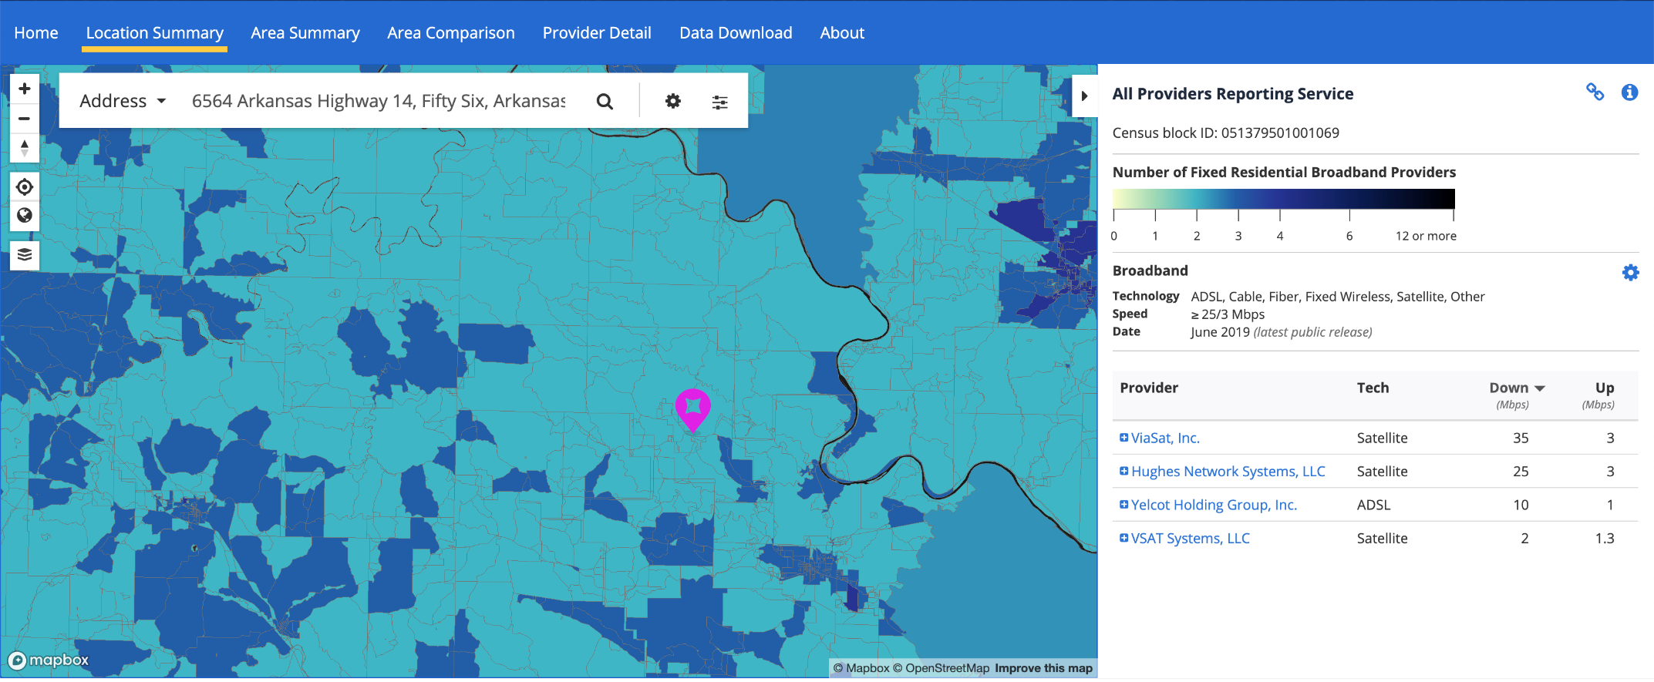

This is the broadband coverage for our county:

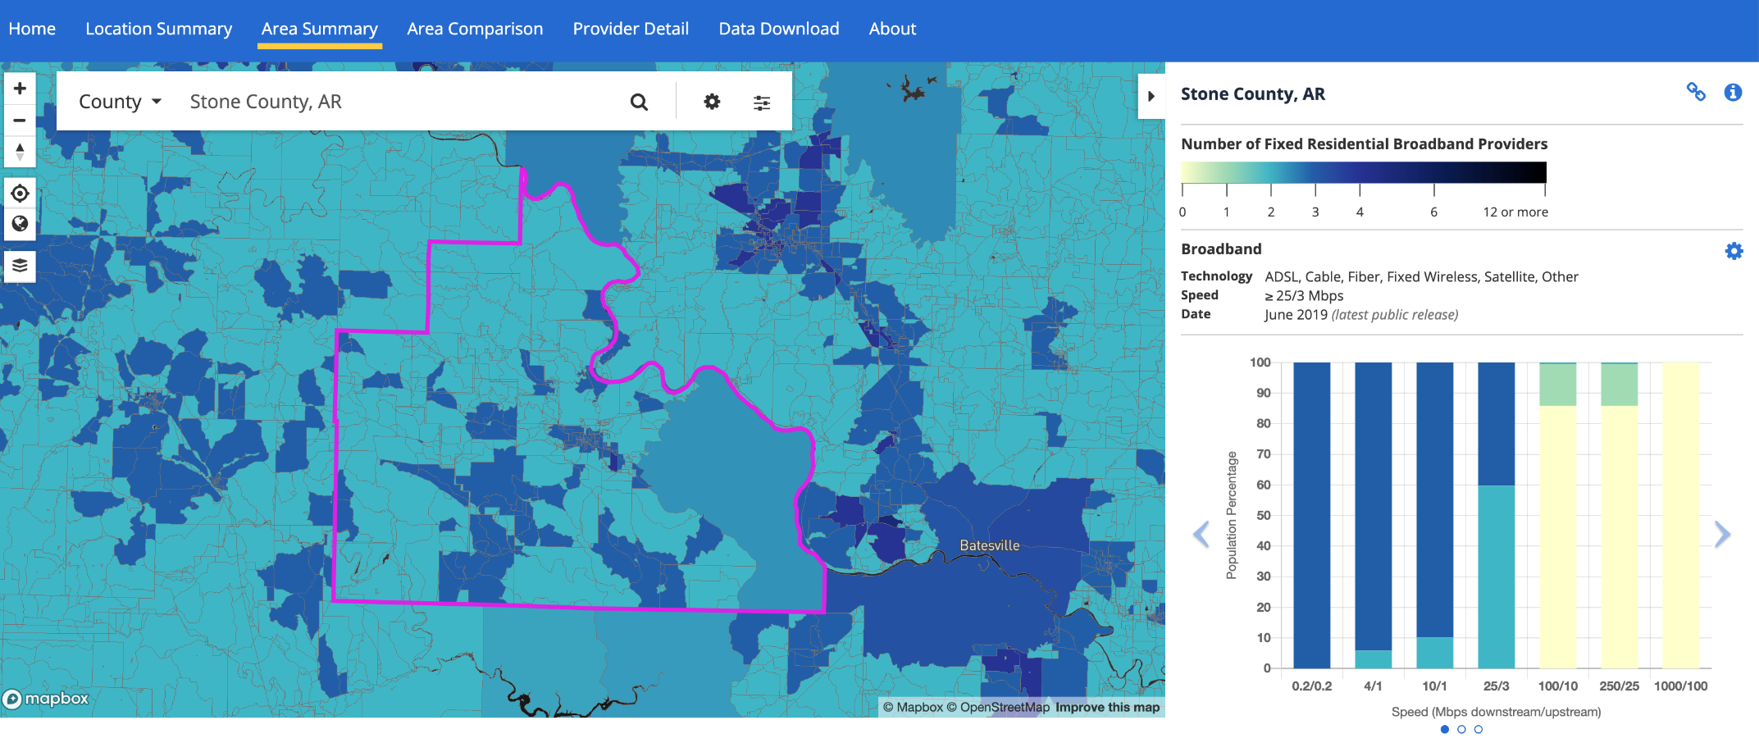
According to the FCC, two providers offer 25/3 broadband to 59% of our county’s residents. Three providers offer 25/3 broadband to just over 40% of our county’s residents.

These maps and data were found at https://broadbandmap.fcc.gov/#/, using the “Location Summary” and “Area Summary” features.

Total population, number of residents who are rural and urban
According to the US Census Bureau 2018 American Community Survey 5-year estimates, Little Township has a population of XXXX individuals. 100% of our area is an urban cluster, as our community has more than 2,500 residents and less than 50,000 residents. We found this data at https://www.census.gov/data.html

Percent of individuals in your proposed service area who are living in poverty
According to the US Census Bureau, Little Township, Arkansas has XX% of residents living in poverty. We found this information at https://www.census.gov/data.html.

Medically underserved
According to the Health Resources and Services Administration MUA Find tool, XXX County is a medically underserved area. We found this information at https://data.hrsa.gov/tools/shortage-area/mua-find.

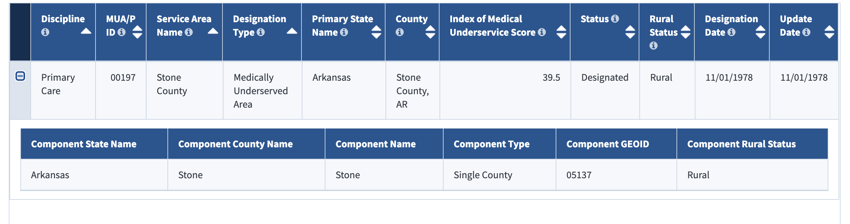

Description of need (up to 30 points)

Staffing needs:
The leaders of Little Township, Arkansas have no broadband experience. However, we do have experience in hiring contractors and consultants, managing budgets, and completing projects on time. Our township administrator handles a budget of $XX,XXX annually and manages X existing contracts for consultants and other contractors. Our township council members have expertise in business relations, forming and convening committees, and our area’s needs.

Population needs:
According to the US Census Bureau Profile for Little Township, Arkansas, the majority of our population (XX%) is over 62 years of age. Our community has a mix of XX% white, XX% black, and X% American Indian residents. Over XX% of our residents experience difficulty living independently and XX% have ambulatory difficulty. The vast majority of our residents (XX%) have a high school degree or equivalent, with XX% having some college or no degree. As of the 2018 estimates, X% of our residents worked at home, although we expect these numbers to be currently elevated due to COVID-19. Males made a median income of $XX,XXX, while females made $XX,XXX. As of the 2018 survey, our employment rate was XX%. We found this information at https://www.census.gov/data.html by entering our township name into the search field and selecting our profile.

Broadband needs:
Although the FCC indicates Little Township has adequate broadband coverage, our experiences are quite different. Our township is home to Little Township Lumber Company and the Little Township Paper Mill, which struggle with customer and employee communication due to the slow and, at times, non-existent broadband connection in their facilities. During COVID-19, some of the lumber company’s and mill’s office workers tried to work from home but slow or non-existent Internet made productivity difficult. Little Township is also home to small businesses which have struggled engaging in online sales and marketing because of a poor bandwidth or lack of broadband. Our township also is home to a K-12 school system, and students and families were largely forced to use the neighboring communities’ broadband “hot spots” to access online curriculum during the COVID-19 pandemic school closures. With an aging population and only one primary care provider in our township, our residents need better access to healthcare in the home, as made possible by broadband connections to remote physicians. However, without adequate, affordable access to broadband in the home, our residents cannot easily access telehealth care. Our businesses and residents stand to benefit from improved broadband. We feel these improvements will most specifically spur economic development in our town and the ability for our residents to participate in online learning and healthcare. We have never received a broadband grant or loan in the past.

Internet Service Provider relationship needs:
Little Township has talked to some of the Internet Service Providers in our region to expand their broadband services to our area and/or increase bandwidth for existing services. The only Internet Service Provider who exhibited interest in this task was XYZ ISP, which will provision to conduct a feasibility study through this grant request in order to determine the needs and business case for expanding their broadband services to our residents. The electric cooperative nearest are our area has not been engaged to discuss broadband possibilities, but we intend to do that through the proposed Little Township Broadband Taskforce.

Financial needs:
Little Township operates on $XX,XXX per year, which pays for our volunteer fire department, roads fund, and annual Christmas parade, along with a salary for X full-time and X part-time employees. We do not know where to begin in bringing broadband to our area, and a grant like this could better define needs, identify options, and determine whether a nearby Internet Service Provider would have the business case to expand their services to our businesses and homes. If we ever will have improved broadband in Little Township, this is our best opportunity, as the funds needed to do this cannot be found in our current budget. We understand there are federal grants available for broadband construction and expansion, and we feel this grant may strategically position us to compete for these funds.

Community relationship needs:
We hold a public hearing meeting once every month to invite business leaders and community leaders to present ideas, plans, and updates for Little Township residents. We have a Facebook page that posts information about our Township, including updates from our leaders. Our local school holds a Parent Teacher Association meeting once every quarter to share updates from our educational leaders and to collect insight from parents. This proposal embodies the needs and requests of these leaders, as all support the idea of improving broadband for the purpose of improving educational attainment, e-commerce, entertainment, and healthcare purposes.

Description of plan (up to 25 points)
Through this study, we plan to achieve the following:
- Contract with a broadband consultant to educate our leaders of broadband options and act as an intermediary in communicating with potential Internet Service Providers in our area.
- Form the Little Township Broadband Taskforce to prioritize broadband deployment throughout our businesses and communities by creating a custom broadband needs assessment for Little Township.
- Engage the XXX Internet Service Provider serving nearby XXX County to conduct a feasibility study to extend their broadband services to our area.

We have considered the following broadband consultants, provided by the UAMS Institute for Digital Health & Innovation Resource Page for this grant:
- 123 Consultant
- XYZ Consultant

We have been in communication with the following Internet Service Provider to conduct a feasibility study. If this vendor is nonresponsive or is met with other issues, we will consider other ISPs and electric cooperatives near our area:
- XYZ ISP

Our objectives and timeline are as follows:

Month 1: Objective – Launch the Little Township Broadband Due Diligence Study
Month 1 Goals:
      - Form the Broadband Taskforce
      - Hold the first meeting of the Broadband Taskforce
      - Assign a taskforce member or hire a contractor to author the custom broadband needs assessment based on the findings of the Taskforce
      - Meet with broadband consultants

Month 2: Objective – Make Decisions Related to the Broadband Due Diligence Study
Month 2 Goals:
      - Hire the broadband consultant, require participation at Taskforce meetings
      - Interview electric cooperatives and ISPs for feasibility study contract
      - Assign a Taskforce member to create the custom broadband needs assessment based on the findings of the Taskforce
      - Continue holding meetings with the Broadband Taskforce

Month 3: Objective – Contract with the Broadband Vendor for the Feasibility Study
Month 3 Goals:
- Determine which electric cooperative or ISP will conduct feasibility study
- Add content and findings to the custom broadband needs assessment
- Continue holding meetings with the Broadband Taskforce

Month 4: Objective – Continuing Documenting Needs
Month 4 Goals:
- Add content and findings to the custom broadband needs assessment
- Continue holding meetings with the Broadband Taskforce
- Receive monthly update about feasibility study

Month 5: Objective – Sharing Documented Needs
Month 5 Goals:
- Share the first draft of the Little Township Broadband Needs Assessment with Taskforce members and UAMS Institute for Digital Health & Innovation
- Make revisions on needs assessment as needed
- Continue holding meetings with the Broadband Taskforce
- Receive monthly update about feasibility study

Month 6: Objective – Receive Findings of the Feasibility Study
Month 6 Goals:
- Share the final draft of the Little Township Broadband Needs Assessment with Taskforce members and UAMS Institute for Digital Health & Innovation
- Feasibility Study findings will be shared at the Taskforce Meeting
- Determine next steps for further broadband grants and loans – or – other steps necessary to act upon the identified needs
Final Products:
- Little Township Broadband Needs Assessment
- Little Township Broadband Feasibility Study

While we are not familiar with broadband grants and loans we may pursue, we understand the XYZ ISP is skilled at pursuing broadband grants, and we have studied the list of grants and loans provided on the Rural Broadband I.D. Trust Fund grant NOFO. It seems the USDA Rural Utilities grants and loans may be our best option for future funding, due to our rural nature. We will lean heavily on our ISP partner to make certain we take this plan as far as possible through future federal grants and loans. While we were preparing this application, we also learned of the USDA Rural Development Loan Grant Program (https://www.rd.usda.gov/programs-services/rural-economic-development-loan-grant-program). If our Taskforce sees fit, we may reallocate some of this request to pay the Needs Assessment Author to help write that grant/loan application.

Budget

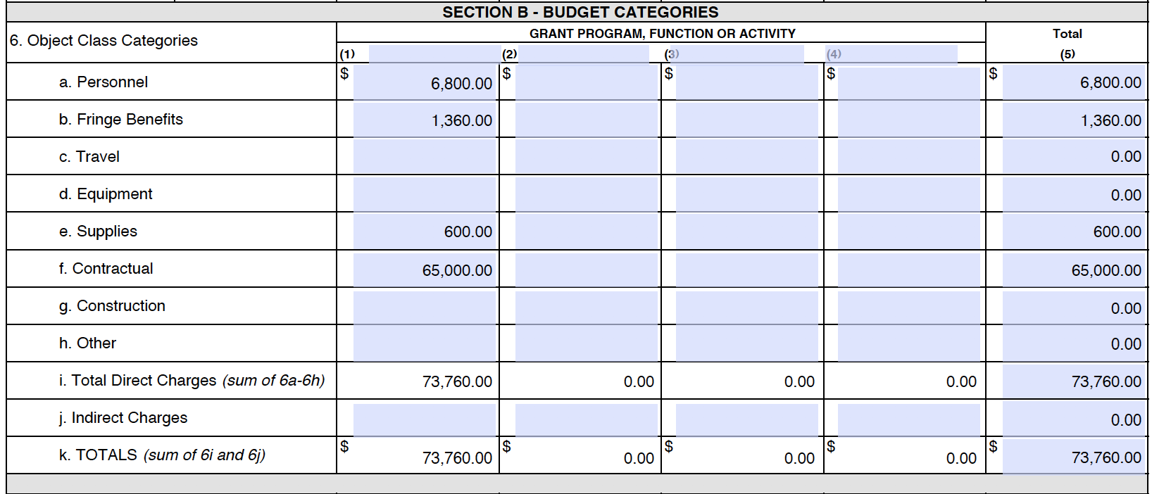

Budget Justification (up to 15 points)

Personnel:
Project Director – Annual Salary $58,000. Our Mayor will act as Project Director, serving as key liaison to the funders and media. She will identify taskforce members and coordinate meetings, making final decisions on all contractors. Our Mayor will spend an estimated half a day a week on this project for six months, accounting for 5% of his annual salary. Request: $2,900

Financial Director – Annual Salary $39,000. Our Township Administrator will act as the Financial Director to this project, securing the surety bond and making financial arrangements for all contractors. He will ensure timelines, objectives, and goals are met, providing troubleshooting as necessary to solve problems while working alongside our Project Director. The Township Administrator will spend an estimated one day weekly on this project for six months, accounting for 10% of his annual salary. Request: $3,900.

Fringe Benefits:
Little Township pays 20% of the salary request for its health, dental, and other insurance.
Project Director: $580 fringe
Financial Director: $780 fringe
Request: $1,360

Supplies:
Little Township will need office supplies (printing paper, printer ink, folders, postage, etc.), bottled water, and other sundry supplies for its Taskforce meetings. An allowance of $100 per month is requested to cover these needs. Request: $600

Contractual:
Feasibility Study Contractor: We believe that XYZ ISP will be the Internet Service Provider to conduct a feasibility study to expand its services to our area; however, our taskforce will decide on the best contractor no later than Month 3. This contractor will conduct market research, engage partners, model/design the network, and conduct a cost analysis and business plan. XYZ ISP has informed us that to conduct this study, they need at least three months and $45,000. We feel this amount will compensate another ISP or electric cooperative should we decide to pursue another feasibility study contractor. Request: $45,000

Broadband Consultant: The Broadband Consultant will educate the taskforce members and larger community as merited on broadband basics and options that are available to them, will coach on future broadband grant and loan applications, and will act as liaison with Internet Service Providers or electric cooperatives to communicate the needs of our community. The Broadband Consultant is vital to improve our broadband understanding, so we can ensure Little Township will be able to negotiate and communicate effectively with Internet Service Providers to ultimately achieve better community-wide access to high-speed Internet. We are respectfully requesting $15,000 to pay this consultant for six months of work. Request: $15,000

Needs Assessment Author: The Project Director will identify a member of the Taskforce or a writing contractor to author the needs assessment. That contractor will receive $5,000 over the course of 6 months to author this document, offer coordination as needed in gathering insight on needs, and conducting surveys as merited for the needs assessment, all of which can be used for future grant and loan applications. Request: $5,000

Supporting documents (up to 10 bonus points)

From the Desk of
Mrs. Helpful

September 14, 2020

Re: Broadband support letter

Dear Mayor:

I have sat on the Little Township Council for five years, and in this time, it has become apparent to me that Little Township needs more technological resources to bring to its residents. Broadband is so often thought of for entertainment – gaming and movies, but it is an essential utility for e-commerce for our small businesses, a means of learning for our students, a method of continuing education for our adult learners, and a way of bringing healthcare into our community and homes. Without good broadband, Little Township cannot reasonably grow. In essence, we are cut off from the rest of the world. I also believe some of our residents, perhaps those who are older adults, should learn about this technology and decide whether and how to embrace the technology in their daily lives. Broadband is a utility that we just can’t live without any longer in Little Township. I feel the Rural Broadband I.D. Trust Fund grant is a possible avenue for us to collect our thoughts, prepare for a larger broadband grant, and align with an ISP or electric cooperative to plan and eventually implement a long-term plan for improved broadband.

I will be honored to sit on your Broadband Taskforce, as I feel I can provide a unique insight into our community needs. Please let me know how I can help.

Respectfully,

Mrs. Helpful
Little Township Council

XYZ
Internet Service Provider

September 14, 2020

Re: Broadband support letter

Dear Mayor:

I am writing to express XYZ ISP’s support for the Little Township’s Rural Broadband I.D. Trust Fund Program grant application. For some time, my ISP has heard from members of your community to see if we would offer broadband services to their home and businesses. By applying for the Rural Broadband I.D. Trust Funds grant, you will have the financial means for us to conduct a broadband feasibility study to see what is needed and how we can help expand our services into your area. Having this information, we will have needed information to seek FCC and other broadband grants and loans to make the broadband expansion possible. We are encouraged that you are committed to this plan and we look forward to seeing how XYZ ISP can serve Little Township with the most reliable and affordable broadband available.

You have our support in seeking more and better options for broadband in Little Township, Arkansas. Moreover, we will be happy to discuss our company and what to expect from the feasibility study during your taskforce meetings or individually with your township leaders as you so wish.

Respectfully,

Mr. Roboto
XYZ ISP

Little Township Paper Mill

Re: Broadband support letter

Dear Mayor:

I am writing to express my support for the Little Township’s Rural Broadband I.D. Trust Fund Program grant application. As the owner of the Little Township paper mill, I must stress the need for adequate, reliable, and affordable broadband to keep workers and also improve productivity among our workers. When COVID-19, many of our office workers were asked to work from home to minimize potential exposure to the virus. However, so few of our office workers had access to broadband at home that at least half of our office workers had to come to the office to work, despite our best attempts to allow a work-from-home schedule. We constantly struggle to accept orders, send purchases, or sync our inventories because of unreliable broadband. Moreover, our current Internet Service Provider, ZZZ ISP, has customer service that falls drastically short of our expectations, and we would like more options by way of wide broadband.

I gladly support your pursuit in improving broadband options in Little Township. I would be glad to serve on your Broadband Taskforce.

Sincerely,

Mr. Papyrus
Little Township Paper Mill

